

**Khulna university of engineering and technology**

**Department of Electronics and Communication Engineering**

***Presented By:***

**Group no: B5**

**Abhrojit Paul Priom (1909043)**

**Sumit Das (1909044)**

**Motiya Rahman Piya (1909045)**

Course Title: **Electronic Circuits Design Laboratory**

Course no: **ECE-2200**

Date of submission: 29.12.2022

***Project name:***

***Variable DC Power Supply***

**Project Supervisor:**

Dr. Md. Faruque Hossain

Professor

Dept of ECE, KUET.

Md. Ebtidaul Karim

Assistant Professor

Dept of ECE, KUET.

**Title:**

DC power supply with regulated voltage and short circuit detection and protection along with under and over voltage detection and protection.

**Motivation:**

The most essential part of an electronic circuit is a power supply. Every electric device, from smaller to the larger one needs an external power supply. In Laboratories, a DC power supply is a must. But all devices can’t be operated at same voltage. Each device has its own optimum ratings, which we can’t exceed. So, such a power supply is needed which is adjustable that is a user might get desired voltage from it. In this project we tried to design and fabricate such a power supply that will be user friendly and will be commercially lower cost having a light weight.

**Introduction:**

Almost every sort of electronic equipment or device needs a DC power supply to function effectively. In this project, we aimed to create a power supply that would be lightweight, user-friendly, and economical from a financial standpoint. The maximum ratings of almost all electronic equipment are known. If the device malfunctions and its maximum rating is exceeded, our power supply will automatically cut the output without causing additional damage. This power supply has the required safeguards, voltage, and current ratings suited for everyday usage of real-world electronic components or for use in laboratories as a variable DC power source with all required indicators. When a power supply circuit is in use, rectifiers, filters, regulators, adjustable components, and protections are all mentioned. Starting with an ac voltage, we rectify the voltage to produce a constant dc voltage. the desired fixed dc voltage is then obtained by regulation after filtering to the desired dc level. Our power supply on the main line typically has a 220V r.m.s. amplitude, which is extremely high for electronics devices and circuits. Greater than 30 is better for electronics. So we used a step down transformer to solve this issue. We used a step-down transformer with a 24V (rms), 1000mA rating in this power supply.

**Objectives:**

The main objectives of this project are:

* To make an adjustable dc power supply.
* To protect the power supply from over voltage.
* To protect the power supply from under voltage.
* To protect the power supply from short circuit.
* To provide sufficient output at under voltage condition.
* To make a cost-efficient dc power supply.
* To design the circuit of dc power supply and implement it on Veroboard.

**Methodology:**

We are experimenting with a DC power supply. To do that, we must first understand what a DC power supply is. A DC power supply is a device that delivers a voltage to its load that has a fixed polarity (either positive or negative). A DC power supply may be powered by a DC source or by an AC source, such as the power mains, depending on its design.

**Apparatus required:**

|  |  |  |  |
| --- | --- | --- | --- |
| **SI No.** | **Apparatus** | **Rating** | **Quantity** |
| **01** | Transformer | 12v*2, 3A | 1 |
| **02** | Diode | 2N4148 | 5 |
| **03** | Potentiometer | 10K | 3 |
| **04** | Capacitor | 100uF, 2200uF | 2 |
| **05** | Resistor | 220, 330, 10K,3,3K | 12 |
| **06** | Op-amp | LM358 | 1 |
| **07** | Adjustable regulator | LM317T | 1 |
| **08** | Fixed voltage regulator | 7815, 7806 | 2 |
| **09** | Ceramic resistor | 330 | 1 |
| **10** | Transistor | BC558, BC547 | 2 |
| **11** | Relay Switch | 12V | 1 |
| **12** | SCR | XL08 | 1 |
| **13** | LED |  | 4 |
| **14** | Switch |  | 2 |

**Circuit Diagram:**

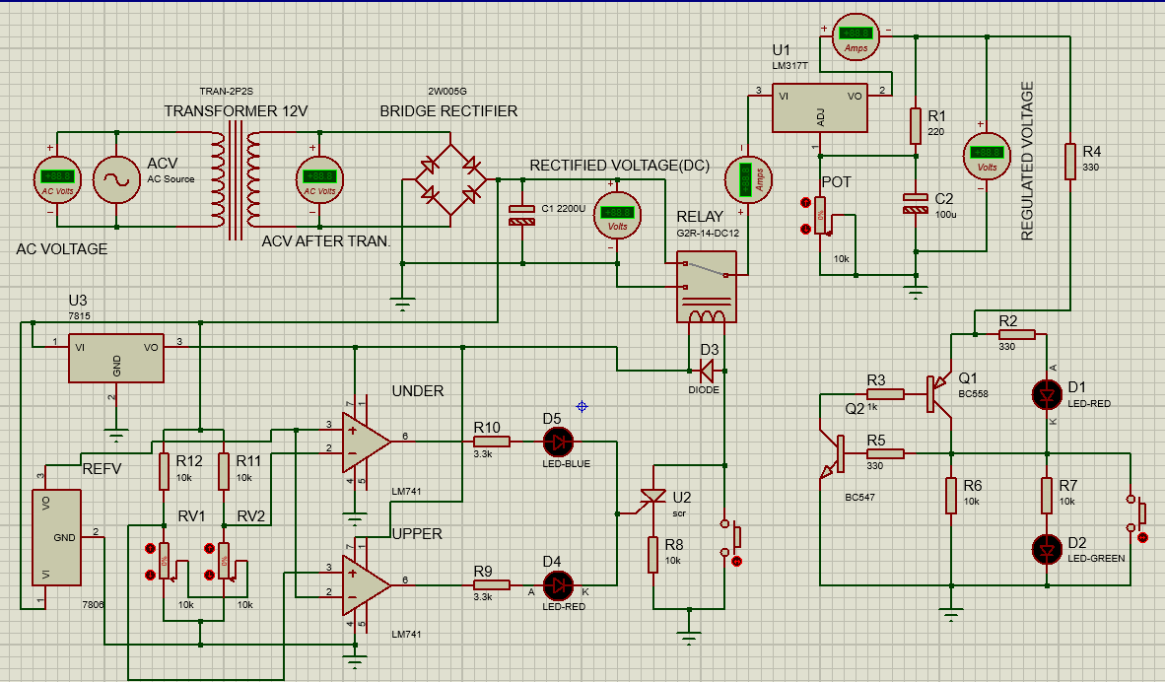

Figure 1: Circuit diagram of Variable DC power Supply

**Block Diagram:**

Under voltage and over voltage protection circuit

Bridge rectifier &

Filter circuit

Input AC supply

Regulator circuit

Load voltage Supply

Short circuit protection circuit

Figure 2: Block diagram of DC power supply

**Circuit Analysis:**

**Bridge Rectifier and filter:**

Bridge Rectifiers use four diodes that are arranged in a way that convert the AC supply voltage to a DC supply voltage. Here we have used a fuse (rating 3 Amp). If the current flow is over 3 Amp, then the fuse will be cut and the transformer will be protected from being damaged. In the first positive half cycle of the AC signal, the diodes D2 and D3 become forward biased and start conducting. At the same time, the diodes D1 and D4 will be reverse biased and will not conduct. During the negative half cycle, the diodes D1 and D4 will be forward biased and diodes D2 and D3 will become reverse biased. The positive voltage will appear on the D4, and negative voltage will be applied to the D1. That’s how we are getting DC voltage as output. Now, C1 is used as a filter for cancelling AC components from the output.

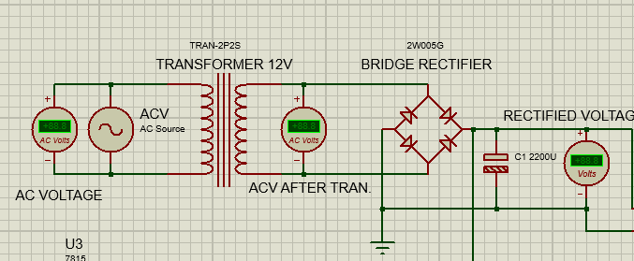

Figure 3: Bridge rectifier witch filter

**Adjustable Voltage supply:**

An adjustable IC (LM317) is used here and rectified 30V is supplied as input in the IC. A 10k variable resistor is used for varying the output. Capacitors are used for making the input and output perfect DC. When the variable resistor varies from 0 to 10k then the output also varies from 5V to 28V.

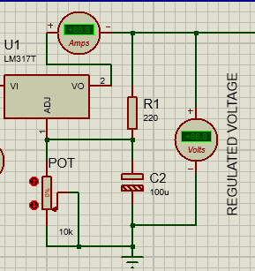

Figure 4: Voltage adjustment and regulation

**Short circuit protection:**

The regulated 0-30 V is supplied through this circuit and a switch is acting as a shorted connection. When the load is short circuited there will be no potential difference between the emitter and base of transistor Q1. So the total current will flow through the transistor Q2 and to the ground which will make the Red LED light. When the short circuit is separated the current will again start flowing through the normal path. This way the load will be protected if short circuit occurs.

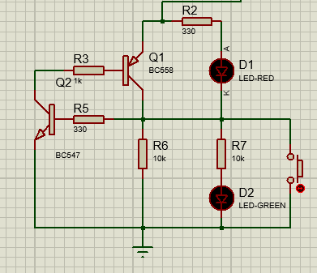

Figure 5: Short Circuit Protection

**Over and Under Voltage protection:**

The rectifier 30V voltage is applied to the voltage divider circuit and 7815 and 7806 fixed voltage regulators. Here the 7815 is working to power up the LM358 op-amp and also give voltage to the relay coils whereas the 7806 voltage regulator is giving a constant voltage which is working as the reference voltage for under and over voltage in the LM358 op-amp. When rectified output changes, input voltage of non-inverting terminal also changes and when it goes above 30V then the comparator gives output voltage and Q3 becomes active and makes LED light. This indicates over voltage.

When rectified output changes, input voltage of inverting terminal also changes and when it goes below 10V then the comparator gives output voltage and Q4 becomes active and makes LED light. This indicates under voltage. The inverting and non inverting terminals are connected according to the pinout of LM358.

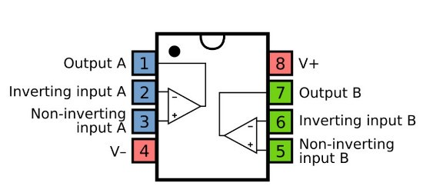

Figure 6: LM358 pinout

We have used Silicon controlled rectifier in our circuit. When voltage passes through the gate and cathode of the scr the anode to cathode terminal also gets voltage and the relay coil connected to the anode terminal gets connected to the ground. As a result the relay gets switched and the short circuit gets isolated.

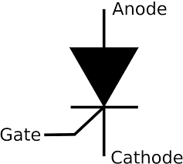

Figure 7: SCR

We have used switches to switch the relay manually and other necessary components to describe the under and over voltage operation.

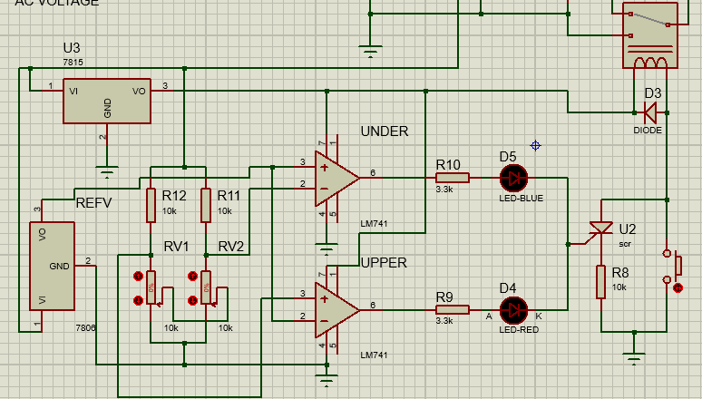

Figure 8: Under and over voltage protection circuit with LM358 and SCR

**Cost analysis:**

|  |  |  |  |
| --- | --- | --- | --- |
| **Name** | **Price(tk)** | **Quantity** | **Total Price(tk)** |
| Transformer | 230 | 1 | 230 |
| Diode | 2 | 5 | 10 |
| Fixed voltage regulator | 15 | 2 | 30 |
| Capacitor | 5+20 | 2 | 25 |
| Resistor | 1 | 12 | 12 |
| Op-amp | 15 | 1 | 15 |
| Adjustable regulator | 15 | 1 | 15 |
| Variable resistor | 25 | 3 | 75 |
| Transistor | 2 | 2 | 4 |
| Ceramic resistor | 20 | 1 | 20 |
| Relay | 30 | 1 | 30 |
| SCR | 2 | 1 | 2 |
| LED | 2 | 4 | 8 |
| switch | 2 | 2 | 4 |

**V-T characteristics curve:**

**Result Analysis:**

* Transformer input = 220V (AC)
* Transformer output = 24V(AC),3000mA
* Output after filtering = +37.1V t0 -37.1V (DC)
* Maximum output current = 300 mA
* Input Supply voltage range for operation=200~245 V(AC)
* Output voltage range= 5V to 37V(DC)
* Minimum Load=100 ohm
* Maximum Load=1 Mohm
* Maximum short circuit current= 40 mA

**Discussion:**

In this design, we've created a DC power supply that provides us with regulated output, over-voltage, under-voltage, short-circuit, and uninterrupted power supply when the circuit is guarding against undesired voltage. Resistor R2 limits the output current at the short circuit protection. Therefore, if one unintentionally grounded the supply, the internal circuit would not be harmed. Fuse once more provides the transformer with protection against damage. But there are certain drawbacks. The circuit has a significant amount of power loss. Our created model is stable at rectified DC outputs of up to 50 volts. This circuit's output ranges from 5 to 37 volts. Circuits in this area are well secured against voltage and short circuits. Although there is a minimum load restriction, the value is also very small. Therefore, our created model can be utilized as a decent source for many purposes, and the maximum output current is only 300 mA.

**Conclusion:**

We have a regulated and adjustable power source thanks to the DC power supply we made. Our circuit is also protected from short circuits, overvoltages, and undervoltages. Due to the equipment's rating being appropriate for this circuit and the total cost being relatively low compared to market prices. Our several upcoming ventures will benefit overall from this project.

**Critical Challenges:**

We were not getting proper output because of the offset voltage of the op-amp in voltage protection circuit. We had to change the op-amp and null the offset voltage to resolve the issue. After that we were facing problem of overheating in the short circuit. Then we used ceramic resistors which can operate in high temperature and high voltage.

**Conflicting Requirement:**

Sometimes a little fluctuation may happen in measurement for accuracy level of regulated voltage and supply voltage to load. If we give a high load resistance of more than 1Kohm then the load voltage and the output voltage of adjustable voltage regulator (LM317T) are always same. But if we give less than 100 ohms say 10 ohm or 50 ohms then there will be around 8v to 12v difference like 28V at adjustable voltage regulator (LM317T) and 16.9V at load. And if we use very high resistance, load current will decrease greatly.

**References:**

* Principles of Electronics-

-by V.K Mehta, Rohit Mehta,S. Chand

& Company,2005.

* <https://en.wikipedia.org>
* [Electronics Projects Circuits (electroschematics.com)](https://www.electroschematics.com/)
* [*http://techlib.com*](http://techlib.com)
* [*http://en.wikipedia.org/wiki/Power_supply*](http://en.wikipedia.org/wiki/Power_supply)
* <https://components101.com/articles/scr-introduction-working-and-applications-in-power-electronics>
* <https://www.youtube.com/watch?v=lKhmNanDkPY>
* <https://instrumentationtools.com/basic-dc-power-supply-circuit/>
* <https://www.homemade-circuits.com/how-to-design-power-supply-simplest-to/>

**Mapping of P’s:**

|  |  |  |  |  |  |  |  |
| --- | --- | --- | --- | --- | --- | --- | --- |
|  | **P1**  **Depth of Knowledge** | **P2**  **Range of Conflicting Requirements** | **P3**  **Depth of Analysis** | **P4**  **Familiarity of Issues** | **P5**  **Extent of Applicable Codes** | **P6**  **Extent of Stake-holder Involvement** | **P7**  **Interdependence** |
| **Tick** |  |  |  |  |  |  |  |
| Justifications | Studying existing models of dc power supplies, gathering information from websites, understanding how to design circuits (K3), integrating various electronic components (K5, K6), and following our supervisors' instructions were all necessary for this project (K4). | Technical conflicting requirements -  It was difficult to examine in circuit the accuracy for both short circuit protection and voltage protection. | There is no readily apparent circuit that would meet those requirements for this project. The logic to connect a certain section of the circuit must be designed. |  |  |  | In this project, software simulation and hardware implementation on a breadboard and a veroboard are interdependent. By examining their applications, output, level of interaction, and dependency with other components, the components used in this project were selected. |

We can explore a few of P’s addressed through this project—

**Mapping of A’s:**

We explore how a few of A’s are addressed through this project—

|  |  |  |  |  |  |
| --- | --- | --- | --- | --- | --- |
|  | **A1**  **Range of resources** | **A2**  **Level of Interaction** | **A3**  **Innovation** | **A4**  **Consequences for society and the environment.** | **P5**  **Familiarity** |
| **Tick** |  |  |  |  |  |
| **Justifications** | This project requires the use of a variety of resources, including people, cash, tools, supplies, information, and technologies. | There must be some degree of interaction between | This project calls for the use of an op-amp as a comparator, the use of a relay switch to operate the circuit in one circumstance as opposed to another, and a certain amount of circuit implementation expertise. |  | The knowledge of engineering graduates in electronics and logic analysis is the subject of this study. |

**Team Contribution:**

|  |  |  |
| --- | --- | --- |
| Name | Contribution | Signature |
| **Abhrojit Paul Priom**  **(1909043)** |  |  |
| **Sumit Das**  **(1909044)** |  |  |
| **Motiya Rahman Piya**  **(1909045)** |  |  |

*Signature of the course teacher*